PART II. NEEDS ASSESSMENT

Decision makers must minimize the [adverse] consequences of emergencies by aligning fire department resources with community risks/hazards (Urban Fire Forum, p. 11).

Chapter 4. DEMOGRAPHICS, EXPOSURES and EXPERIENCE
This chapter addresses the Committee Charge to: “2. Complete a needs assessment for Fire Protection within the Town of Mendon” (Resolution 22-150).

DEMOGRAPHICS
The Town of Mendon was organized in 1813 and annexed from Ontario County when Monroe County was formed in 1821 (Town of Mendon Website, 10.5.22).
Approximately 39 square miles, the Town of Mendon has contiguous boundaries with both Ontario and Livingston Counties. Mendon is bordered on the north by the Town of Pittsford, on the west by the Towns of Rush and Henrietta, on the south by the Towns of Lima (Livingston County) and West Bloomfield (Ontario County) and on the east by the Town of Victor (Ontario County).
Like the Village of Honeoye Falls, there is no direct access to the Town from an Interstate highway. Regional access is provided by Interstates 390 and 490, and then via local, County and NYS roads. The New York State Thruway (I-90) passes through the northeast corner of the Town. NYS Routes 64 and 251 intersect at the 4-corners of the Mendon Hamlet.
The Village of Honeoye Falls, located in the southwest portion of the Town, has the highest density in the Town and is a retail center. The Hamlet of Mendon, on the east side of the Town, also serves as a commercial and residential area. Both areas are the historic centers of population and commerce (Mendon Comprehensive Plan, p. 2).
The Village of Honeoye Falls was Incorporated in March, 1838 by an Act of the New York State Legislature. Named for the waterfall on Honeoye Creek, it is 2.6 square miles within the Town of Mendon, in southeast Monroe County. Regional access is provided by Interstate 390. Access in the greater Rochester Metropolitan area is via NYS Routes 15A, 251 and 65, bringing travelers to the 4-corners at the center of the Village.
Basic demographic information is relative in discussions about Fire Protection. These factors are rated by the New York State Comptroller’s 2021 Environmental Stress Report. Both the Village of Honeoye Falls and the Town of Mendon achieved a score titled, “No Designation” (NYS Comptroller, 10.24.22), meaning there is no problem with the action of either local government. The Environmental Stress Reports are in Appendix 4-1.
Several categories included in the scoring rank are relevant for our consideration. They influence our collective ability to sustain community expectations for Fire Protection Services. In this chapter, we detail factors related to:
- Staffing…population, age
- Equipment; and,
- Financing…poverty, tax base, income, unemployment, State and Federal Aid.
Population and Age
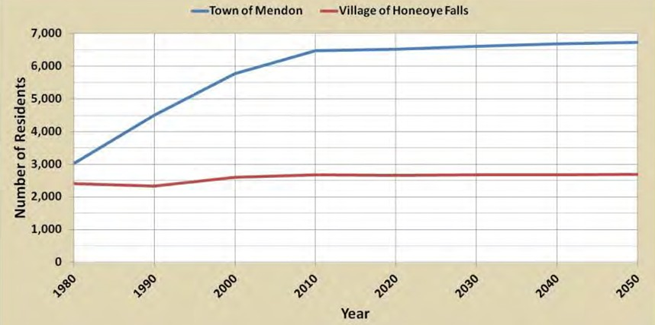
“Population history for the Village was obtained from the Genesee Finger Lakes Regional Planning Council and the 5-Year American Community Survey (ACS) as shown [above]. The Village’s population has been relatively steady since 1980 and is expected to remain steady over the next few decades. By comparison, the Town of Mendon’s population nearly doubled between 1980 and 2010. From 2010 to 2019, the Town of Mendon’s population continued to increase from 8,982 to 9,203. Unlike many local villages, Honeoye Falls has nearly 450 undeveloped acres within its corporate limits. Based upon the available land and the desirability of the community, it is reasonable to assume there will be additional growth in the number of residents living in the Village over the next decade (2022 Village Comprehensive Plan, p.17”.
“Population: Village of Honeoye Falls, 2000 – 2019”
Age | 2000 | 2010 | 2019 | New Change | % Change
19 and under | 679 | 734 | 700 | + 21 | + 3.1%
20 – 34 | 373 | 365 | 435 | + 62 | + 16.6%
35 – 54 | 817 | 829 | 690 | - 127 | - 15.5%
55 – 64 | 245 | 340 | 396 | + 151 | + 61.6%
65 and over | 481 | 406 | 538 | + 57 | + 11.9%
TOTAL | 2,595 | 2,674 | 2,759 | + 164 | + 6.3%
Median Age | 41.2 | 41.9 | 41.2
Source: US Census (2022 Village Comprehensive Plan, p. 18).
Excluding the Village, the Town of Mendon is currently home to 6,498 people. Population within the Town (excluding the Village) increased 12.2 % between 2000 and 2010, but remained fairly stagnant between 2010 and 2017, while the Village population steadily increased by 6% between 2000 and 2017 (Mendon Comprehensive Plan, p. 10).
These numbers are estimated by the Genesee-Finger Lakes Regional Planning Council and reported in the 2021 Town of Mendon Comprehensive Master Plan, p.11:
U.S. Census
Year: | 1990 | 2000 | 2010
Town outside Village | 4,505 | 5,775 | 6,478

The U.S. Census Bureau’s 2000 and 2010 SF1 Decennial Censuses, and the American Community Survey 2013 – 2017, report the Median Age of Residents (Mendon Comprehensive Plan, p. 11):
Median Age of Residents
Year: | 2000 | 2010 | 2017
Town outside Village | 39.8 | 43.6 | 45.8

Housing Stock
The majority of the housing stock in the Town outside the Village (52.6 %) was built after 1979. In the Village of Honeoye Falls, the majority (51.2 %) was built in 1959 or earlier. These are the American Community Survey, 2013 – 2017 estimates (Mendon Comprehensive Plan, p. 18):
Percentage of Housing Stock by Age
 | 1939 or earlier | 1940 -59 | 1960 - 79 | 1980 – 99 | 2000 or later
Town outside Village | 27% | 5.3% | 15.1% | 36.8% | 15.8%
Village of HF | 33.1% | 18.1% | 26.5% | 15.9% | 6.4%

Residential building activity is administered independently by each local government. Pending and projected development should be considered in real time by parties directly involved in discussions about Fire Protection as land use impacts exposures relating to apparatus requirements and staffing complements.

Page 17

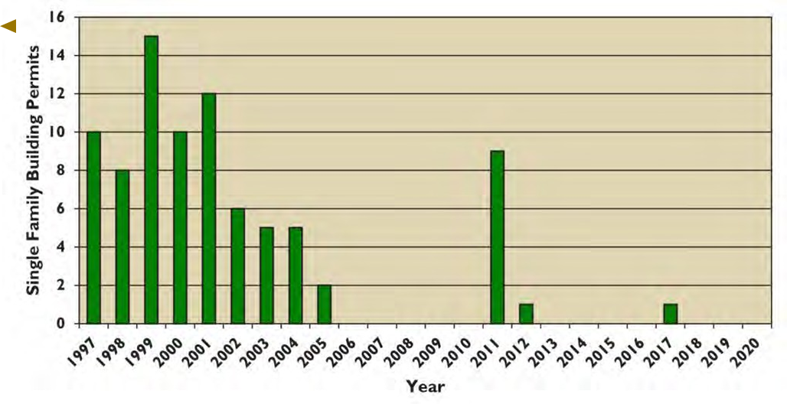
As indicated in the graph above, the Village “has issued a total of 84 permits for new homes from 1997 to 2020. The number of permits issued started a five year decline in 2002. This decline continued through 2006, when the number of permits issued dropped to zero. This inactivity continued for four years from 2006 through 2010.
“There were a total of 10 Certificates of Occupancy (C of Os’) issued by the Village for single-family homes from 2003 to 2013. Only one was issued from 2006 through 2010. C of O’s differ from building permits in that they are an indication of homes built and occupied. Whereas, the issuance of a building permit does not necessarily mean construction was realized“ (2022 Village Comprehensive Plan, p.20).
Similar information for the Town of Mendon, outside the Village, is expressed on Figure 4-1 (Gates, 10.12.22).
Financial Capacity
Residential income is a valid indicator of the population’s ability to sustain local government services and should be a priority consideration as the Town discusses Fire Protection. The majority of revenue for the delivery of Fire Service is the property tax levy and summary data across multiple years of the NYS Comptroller’s annual “Environmental and Fiscal Stress” reports may suggest trends and indicate patterns related to our population’s age and income.
Figure 4-2, is the Real Property “Classification Listing” (Town Assessor, 8.29.22).
Appendix 4-2, contains detail for the Village on the aggregate and individual Assessed Value of these parcels: by their Major Classification Type; by their individual Classification Number Classification; for County/Town, School and Village Tax levies; and, for certain Exemptions. Appendix 4-3, is a like presentation for the Town outside the Village (Town Assessor, 8.29.22).

EXPOSURES and EXPERIENCE
Land Use
“Residential and agricultural land uses dominate the Town of Mendon landscape. Together, these two land uses account for 71 percent of the land use within the Town by acreage. Outside of the Village, the only commercial center is in the Hamlet, and just 0.4% of land within the Town is classified as commercial. Commercial and mixed-use properties are clustered within the Hamlet and generally include a variety of small scale independently-owned shops, restaurants, and office space. Together, vacant land and wild / parkland (including Mendon Ponds Park) account for just over 25% of land use.
“The land uses are based on real property data from Monroe County and can be described briefly based on information from the New York State Office of Real Property Services and sourced to Monroe County GIS. The quoted percentages include the Village:
• 49.7% Residential – property used for human habitation (single family, multi-family housing) but not including hotels/motels.
• 21.6% Agricultural – property used for the production of crops or livestock.
• 14.9% Vacant Land – property that is not in use, is in temporary use, or lacks permanent improvement.
• 10.5% Wild/Parkland – Reforested lands, preserves and private hunting/fishing clubs.
• 3.3% Other – all other uses, including commercial and industrial uses, that represented a small share of land acreage in the Town” (Mendon Comprehensive Plan, p. 19).
With few exceptions reserved to New York State, land development and Plat division is governed by Local Law. Figure 4-3, is a map of the Town of Mendon Zoning Districts (Gates, 10.12.22). Figure 4-4, is a map of the Village of Honeoye Falls Zoning Districts, Adopted August 19, 2019 (Village website, 12.16.22).
The Committee identified and developed a menu of likely and potential risks associated with our natural and built landscapes. We label them in two (2) categories: Target Features and Natural Features. The Committee did not prioritize the risks. We name them, define them for our purpose, state their exposure and identify the service demand required to terminate the inherent emergent condition(s).
Our local Fire Departments are trained and equipped to respond to emergency calls associated with these risks. Their capacity can grow through Mutual Aid, Mutual Assistance agreements, Special Operations Teams and from municipal forces as prescribed in Department protocol and/or at the request of the (Department) Incident Commander, or the Chief Elected Official with A State of Emergency Declaration.

Target Features (separate document for now)

Natural Features (separate document for now)

12.19.22

