PART I. GOVERNANCE and DELIVERY

PART I. addresses the Committee Charge to: “1. Identify the current framework of jurisdictional authority [Chapter 2] together with the current capacity to deliver Fire Protection within the Town of Mendon [Chapter 3]” (Resolution 22-150).
Every emergency is local. An emergency occurs at a specific location, at an ascribed time, and affects a person or people.

Chapter 2. AUTHORITY and JURISDICTION
Emergency Services may be structured a number of ways. State Law prescribes structural organization and operational authority, but reserves decisions about functional capacity and service delivery to the local governing body of each organization. New York State Consolidated Laws offer options to local elected officials who are vested with the authority to deliver Emergency Services including Fire Protection, Emergency Medical Service, Centralized/Special Services and Emergency Management (Meisenzahl, 10.12.16).

AUTHORITY
Local governments, New York’s counties, cities, towns and villages, “look to the State Constitution and the state statutes for the basic law which provides for their structure, powers and operational procedures (Cuomo and Shaffer, p. 46). These are ‘general purpose’ units of local government, and are by law, ‘municipal corporations.’ In addition, local government also includes a number of other specialized districts and entities, such as fire districts [and authorities], which usually provide a single service in a limited area” (Cuomo and Shaffer, p. 45).
Elected officials have authority to take actions through local laws, resolutions and other means to ensure delivery of services to protect resident health, safety and welfare at county, town and village levels. General purpose governments and a number of special districts and authorities currently engage to structure and deliver Fire Protection services within the Town of Mendon.
In addition, there is, “… a significant amount of joint service sharing authorized under General Municipal Law…for inter-municipal cooperation for related fire protection activities” (Parshall, p. 21). Some of these examples are noted on Figure 2-1., “Municipal Resources & Contracts for Service.” State Statutes recognize that some emergency services are better suited in a structure that spans municipal boundaries and/or territorial jurisdictions of local fire and EMS agencies. For example, counties are authorized to provide special services that may be centralized to offer universal support for local Emergency Services:
- “Establish and maintain fire training schools to train firefighters
- “Establish and maintain a central fire alarm system
- “Create a county fire advisory board
- “Create the office of county fire coordinator
- “Coordinate interoperable and emergency communications…including those related to public safety land mobile radio communications
- “Establish and maintain a mutual aid plan
- “Develop a plan for arson investigation
- “Develop a plan for hazardous materials incident response, and establish an emergency response team
- “Establish, maintain and supervise municipal-wide and inter-municipal specialized emergency response teams
- “Coordinate Emergency Management planning, response and recovery

Note. The preceding bullet points are respectively noted in New York State:
- County Law, Sections: 225.1.(g) and (h); 225-a.; 326; 327; 328; and, 328-b. (FASNY, pp.22-23, 24-26)
- General Municipal Law, Sections: 209; 204-c; 204-f; 209-j; 209-y; and,209-bb (FASNY, pp. 256, 245-246, 266, 269, 260)
- Executive Law, Article 2-B, Section 23 (FASNY, pp. 70-71).

An Authority is, “[a] ‘public benefit corporation’ [which] more precisely defines the many special purpose agencies in this category. The traditional purpose of the public authority has been to construct, operate and finance a specific type of improvement” (Cuomo and Shaffer, p. 135). Public Authorities have direct and indirect roles with Emergency Service providers.
As described in its 2021 Report, and in accordance with its purpose to supply, treat and deliver water within its prescribed regional territory, the [Monroe County Water] Authority “produced and delivered an average of 60 million gallons of water each day…” (MCWA 2021 Report, p. 1), including its contracts with the Town of Mendon and the Village of Honeoye Falls.
Village of Honeoye Falls: (sales in 1000 gallons) 65,833 to 861 customers
Town of Mendon: (sales in 1000 gallons) 127,851 to 1937 customers (2021 Report, p. 12)
Customer billing is separate from local municipal fees. Authority-wide charges and consumption/usage fees are billed directly to its customer base.
New York State authorizes the organization of Fire Protection services as, “… a function of cities, village governments, and town special districts. State law…prohibits town and county governments from offering fire protection as a municipal function. As more densely populated places, fire protection was assigned as a municipal responsibility under General City and Village Law. In towns…the provision…was accommodated through the creation of special districts within the town, allowing costs to be assessed to areas based on need of services…” (Parshall, p. 6).
As described in the illustration below, fire protection jurisdictions authorized by New York State statutes are:
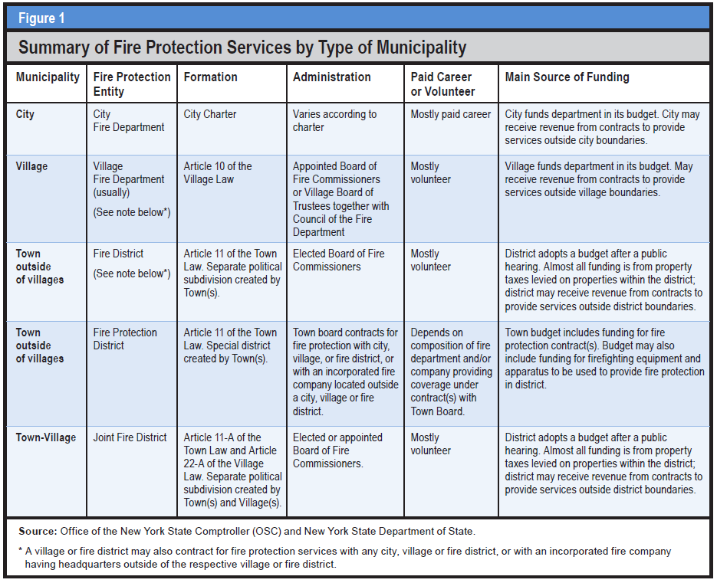
NOTE: The source for Figure 1, above, is the New York State Comptroller’s Report, Fire Protection in New York State: How Is It Provided in Your Community? p. 3.
Villages
“In New York [State]…villages are required to provide fire protection services as a municipal function… . That protection is provided on a…village-wide basis by a municipal fire department. Village fire departments are established under Village Law, Article 10 and are administered by an appointed board of fire commissioners or the village board… . Village departments may also be contracted to provide fire services to areas of their embracing town(s) that are outside the village boundaries. Another option for villages is to form a joint [fire district] (Parshall, p.7)…which operates similarly to an independent fire district. Municipal fire departments…are funded by the general tax levy of the city or village” (Parshall, p. 9). Fire protection contract revenue is a general revenue source.
The Village Board of Trustees is a five-member board comprised of a Mayor who has separate and distinct Executive authority by New York State statutes together with Legislative authority, and four Trustees who have Legislative authority. These are all compensated, four-year term positions. Regular Honeoye Falls Village Elections are held in odd-numbered years on the third Tuesday in March.
The Village Fiscal Year is prescribed in New York State Village Law, Section 5-500.4 and is June 1st through May 31st (FASNY, p. 749). And, the Official Village Year, “…begins at noon on the first Monday in the month following the date of the general village election” i.e., April (Village Law, Section 3-302.1).
“The 2022 local government entities list, published by the Office of the State Comptroller, indicates there are 1,084 municipal and incorporated fire departments” in New York State (Parshall, p. 12).
Towns
[Towns were] “…involuntary subdivisions of the state, constituted for the purpose of the more convenient exercise of governmental functions by the state for the benefit of all its citizens. Towns were finally granted full membership in local government partnership…when they were constitutionally granted home rule powers [by the State Legislature]…in Town Law, Article 1, Section 2: A town is a municipal corporation comprising the inhabitants within its boundaries, and formed with the purpose of exercising such powers and discharging such duties of local government and administration of public affairs as have been, or, may be conferred or imposed upon it by law” (Cuomo and Shaffer, p. 99).
“Virtually all of a town’s discretionary authority rests with the town board. [The supervisor’s executive power], is granted by specific statute or by the town board. The town board, therefore, exercises both legislative and executive functions, which accounts for the variance in authority of the Supervisor as Chief Elected Official for a town, and a village mayor with specific Executive authority as Chief Elected Official” (Cuomo and Shaffer, p. 102).
The Supervisor and four (4) Town Board members comprise the Mendon Town Board. The Town Clerk, Highway Superintendent and two (2) Town Justices also have authoritative roles that intersect with the town’s responsibility for Emergency Services. All are compensated, elective offices with designated terms. General Town Election is held the first Tuesday of November in odd-numbered years. The Town’s Official Year, and its Fiscal Year are concurrent with the calendar year: January 1st through December 31st.
Fire Protection…“Is not a town function, since it can only be provided in towns through the medium of districts…” (Cuomo and Shaffer, p. 108). Fire Protection outside the corporate limits of a Village is authorized in Town Law, Article 11 and Article 11-A. (FASNY, pp. 626-669). “This service may be provided by one or more fire districts, fire protection districts, or – not uncommonly – a combination of both” (NYSOSC, p. 5).
“These districts are used for the provision or the contracting of fire services, allocating the costs to property owners served by that district. The creation of either…can be initiated by a town board…or via a citizen petition signed by residents owning real property…within the proposed district, subject to town board approval. While the terms are similar and often used interchangeably in popular reference, an independent fire district and a fire protection district are legally different entities…” (Parshall, p. 8).
Fire Districts. New York State Town Law, Section 11-170, authorizes Town Boards to establish a fire district,”…provided, however that any such district or extension shall be outside of any incorporated village…or existing fire protection district” (FASNY, p. 626).
“Independent fire districts are public corporations created by a town (or towns jointly). Once incorporated, fire districts are autonomous and independent entities, or district corporations, under the New York State Constitution with the independent power to levy taxes and incur debt. They are special purpose, rather than general purpose governments, but [they] are distinct local governments. [They] are subject to state statutory taxation and expenditure limitations, including New York State’s property tax cap. They are not, however, subject to constitutional debt or tax limits.
“…They have an independently elected governing board – a five-person board of commissioners. The commissioners adopt rules and regulations governing all fire departments and companies within the district. Fire district elections are annually held the second Tuesday of December, off-cycle from town and village elections” (Parshall, p. 11). Town Law, Section 176 enumerates the “powers and duties of fire district commissioners” (FASNY pp. 640-650).
A fire district, “may contract with a city, village, fire district or an incorporated fire company headquartered outside the district for fire protection services. A fire district may also provide coverage outside the district pursuant to contract or a call for assistance.
“Generally, a fire district can levy taxes and incur debt without approval from any other government. It is responsible for adopting an annual budget…and, once approved, the district budget is filed with the town. The town board cannot change a fire district budget. As a rule, the town must attach the fire district budget to its own budget and submit them to the county. The county then levies the fire district tax, and the tax is collected by the town and turned over to the fire district” (NYSOSC, p.5).
The 2022 local government entities list, published by the Office of the State Comptroller, indicates there are 902 fire districts in New York State” (Parshall, p. 11).
Fire Protection Districts. New York State Town Law, Section 11-184, authorizes the Town Board to establish a fire protection district and provide fire protection within the district. These are not separate units of government and they are not political subdivisions of the state (DiRaddo, Chapter 23:10). “As with other types of town special districts (water, lighting), a fire protection district is an administrative area of the town” (NYSOSC, p. 8), and, “their parent town retains the authority to create, alter, or dissolve them…” (Parshall, p. 12).
Fire protection districts, “…are established for the sole purpose of providing fire protection by contract…to provide fire protection to the district (Cuomo and Shaffer, pp. 134, 135). “A town board can create a fire protection district, consolidate adjoining fire protection districts, alter the boundaries of a fire protection district, or dissolve a fire protection district on its own motion or by petition” (Dallessandro, p. 17).
Section 184 also considers Fire Protection Contracts – the process, length, terms and payment (FASNY, pp. 660-661). The town board may contract, “with any city, village, fire district or incorporated fire company” for both firefighting equipment and personnel to operate the equipment (DiRaddo, 23:10). “Towns contract for fire protection services within these districts at the expense of the property owners in that district” (Dallessandro, p. 16).
“Any contract must specify a ‘definite sum’ for all services rendered under the contract and must be for a definite period of time…” (NYSOSC, p. 8). Most contracts are reviewed annually and can be renegotiated and can be amended by the town board. Still, the operational details are not in their direct control” (Parshall, p. 12).
The cost of the contractual services, together with certain statutory liabilities of the area arising from the furnishing of fire protection, is then levied against the properties of the district on the annual tax roll” (Cuomo and Shaffer, pp. 134, 135). Fire protection district contract costs, “are included within the town’s property tax cap levy…and, must be uniform across the entirety of the fire protection district.
“The 2022 local government entities list, published by the Office of the State Comptroller, indicates there are 887 fire protection districts… in New York State” (Parshall, p. 12).
The cost of fire protection for residents of Fire Districts and Fire Protection Districts is disparate as Districts and Fire Contracts are both separately determined by their respective Authority. Figure 2-2. illustrates the cost for residents of Monroe County who receive Fire Service from Districts and Contract delivery.
Joint Town-Village Fire Districts. “Another option for towns and villages is to create a joint fire district under Town Law 11-A and Village Law, Section 22-2210. These may be established when deemed in the ‘public interest’ by a joint resolution of the village and town boards, following public hearings, and subject to approval at referendum. Establishment requires the dissolution of any existing fire districts or fire protection districts in the joint district territory. Joint fire districts must have contiguous territory. [They] operate similarly to independent fire districts. Their budgets are adopted by an elected board of commissioners (subject to public notice and hearing requirements). As with independent fire districts, joint village-town districts are independent municipalities that must comply with state financial reporting and auditing requirements” (Parshall, pp. 16-17).

JURISDICTION
Mendon Fire District #1. At a Special Meeting on March 7, 1935, ...in accordance with sections 170 and 171 of the Town Law, the Town Board Resolved - That the creation of a Fire District as asked for under said petition is for the public interest and that the owners of property included in the district are benefitted thereby and that we approve of the boundaries of said district as shown on map filed. The Board also resolved to appoint five (5) residents as officers and one (1) additional resident as Treasurer of the newly created Mendon Fire District #1 (Minutes of Meeting, pp. 188, 189). Appendix, 2-1.
And, at a Regular Meeting on November 7, 1935, …it was voted to raise the following amount for [Mendon] Fire District #1…$500.00 (Minutes of Meeting, p. 217).
As a political subdivision, the district has all authority granted by state statute, including taxation, and governance through its elected Fire Commissioners who determine an annual budget and set the tax rate (Shaughnessy, Part XI). NOTE: Figure 3-32. indicates this taxable assessment for the Fire District from 2000 through 2023.
Emergency and general ambulance service are contracted [within District territory] by the Town of Mendon, pursuant to a Home Rule request for special legislation from New York State.
The District engages with other elected Commissioners and authorizes its officers and employees to attend professional meetings and seminars conducted by organizations that advocate for the Fire Service and their mission. Examples are the: New York State Association of Fire Districts; and, the Monroe County Fire District Officers Association. Across many years Mendon Fire District Officers have assumed leadership roles with these organizations and their affiliates, including President of both the County Association and the State Association.
The Mendon Fire Department has been serving the District since its creation, and protecting the Hamlet of Mendon and its surrounds before 1935.
Town of Mendon Fire Protection District No.1. As previously stated, New York State Town Law, [now] Section 184, authorizes the Town Board to establish a fire protection district and “provide for the furnishings of fire protection within the district” (FASNY, p. 660). Fire protection districts are not separate units of government and are not political subdivisions of the state. They are created and controlled [i.e. governed] by the town board.
At a Regular Meeting of the Mendon Town Board on October 16, 1939, It is hereby resolved – that this Board find and determine upon the evidence given at such hearing [September 18, 1939]; that it is in the public interest to establish the said fire protection district. And, it is further resolved – that, pursuant to [then] Section 171 of the Town Law, State of New York, there be and hereby is established a fire protection district within the Town of Mendon, to be contained in and embrace the following boundaries to wit: …(Minutes of Meeting, p. 368). Appendix 2-2.
At a Special Meeting of the Mendon Town Board on November 14, 1939: The Supervisor stated that the meeting was called to approve or disapprove of the [prepared] Contract between the Village of Honeoye Falls and the Mendon Fire Protection District for Fire Protection to be furnished by the Honeoye Falls Fire Department. The Contract as prepared is as read to the meeting by the Town Attorney… (Minutes of the Meeting, p. 375). And on December 11, 1939, the Town Board executed a contract with the Village of Honeoye Falls for the Honeoye Falls Fire Department to provide its full menu of services to this territory. The Meeting Minutes and the original Contract are in Appendix 2-3.
Since Fire Protection District #1 was created, the Town of Mendon has contracted with the Village Board of Trustees for fire protection with the HFFD. And, based on the Taxable Assessed Value of the Fire Protection District provided by the Assessor at the time the Budget is adopted, the Town Board determines the tax rate for Fire Protection District #1 in its annual budget and collects the district tax on its annual property tax bill. NOTE: Figure 3-33. indicates this taxable assessment for the Fire Protection District from 2000 through 2023.

1.23.23

